**Test Driven Development**

In the previous lessons, we looked into various approaches to software development, and while choosing a well-structured development process is essential to developing high-quality software, it is equally important to have an effective​ testing process that can ensure that all software requirements are being met. While there are multiple approaches to software testing, the most prominent is *test driven development*, and that is what we will be discussing in this lesson.

Test driven development [#](https://www.educative.io/courses/web-development-a-primer/NE785yVp1l8#test-driven-development)

**Test-driven development** is an approach to program development in which you interleave both testing and code development. Essentially, you develop your code incrementally and also simultaneously develop a test for each increment. You don’t move on to the next increment until the code that you have developed passes its test.

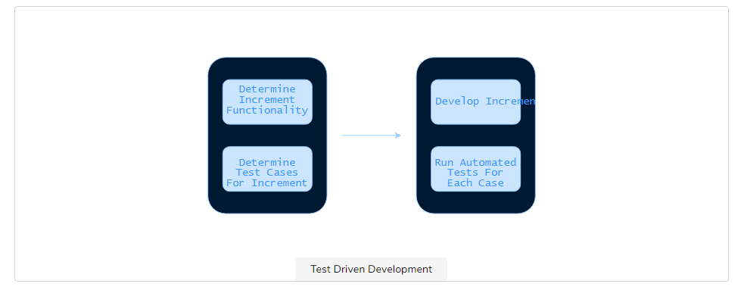

Automated testing [#](https://www.educative.io/courses/web-development-a-primer/NE785yVp1l8#automated-testing)

The core idea in test-driven development is to simultaneously develop automated tests with each increment and ensure the tests are passed. Tests are automated using APIs that automate browsers and execute test cases without human intervention. **Test cases** refer to the multiple features a web application intends to cater to, and testing requires a test to be developed for each test case. In the rest of the lesson, we will be discussing some popular testing tools that may be helpful.

Selenium [#](https://www.educative.io/courses/web-development-a-primer/NE785yVp1l8#selenium)

[Selenium](https://www.seleniumhq.org/) is one of the most commonly used tools for web application testing. Its primary purpose is to automate browsers, which means that Selenium allows for tests that can automatically access the application being developed and check if the intended functionality has been implemented correctly. The gist of Selenium is that it allows users to define a set of activities for a web browser to carry out so applications can automatically be opened and tested through the tool, just like a human would test functionality manually.

Jest [#](https://www.educative.io/courses/web-development-a-primer/NE785yVp1l8#jest)

[Jest](https://jestjs.io/) is an integrated, “zero-configuration” JavaScript testing tool that is often used by Facebook to test all of its JavaScript code, including React applications. Jest works with every compile-to-JavaScript language and integrates seamlessly with Babel which means you can write React, TypeScript, and much more without configuration.

PyUnit [#](https://www.educative.io/courses/web-development-a-primer/NE785yVp1l8#pyunit)

[PyUnit](https://docs.python.org/2/library/unittest.html) refers to the Python unit testing framework. A **unit test** targets a small unit of code, such as a method that implements a particular functionality. Also known as unittest, PyUnit supports test automation, the ability to share setup and shutdown code for tests, aggregation of tests into collections, as well as the ability to keep tests independent from the reporting framework. PyUnit is, therefore, an essential tool in testing the intended functionality of a given web application.

JUnit [#](https://www.educative.io/courses/web-development-a-primer/NE785yVp1l8#junit)

[JUnit](https://junit.org/junit5/docs/current/user-guide/) is the Java equivalent of PyUnit, and it enables users to write unit test cases in the Java programming language.

JUnit, like PyUnit, has been important in the development of test-driven development and is one of a family of unit testing frameworks collectively known as [xUnit](https://en.wikipedia.org/wiki/XUnit).